# Introduction

## Motivation

Many coral reefs around the world are impacted by terrigenous sediment from anthropogenic watershed disturbances like industry, agriculture, deforestation, roads, and urbanization (Burke et al., 2011; Halpern et al., 2008). Land cover change can alter the timing, composition, and mass of sediment loads to coral reefs, causing enhanced sedimentation on corals near the outlets of impacted watersheds (Syvitski et al., 2005). Impacts of these land cover changes are exacerbated on tropical islands characterized by high rainfall, extreme weather events, steep slopes, erodible soils, and naturally dense vegetation, where land clearing alters the fraction of exposed soil much more than in regions with sparse vegetation. Sediment can bond with and transport other pollutants, attenuates light for photosynthesis, prevents larval recruitment, and stresses or smothers the coral organisms (Fabricius, 2005). Deposited sediment can be resuspended due to wave action and reworked over the reef, causing persistent negative effects to ecosystem health (Wolanski et al., 2003) and distributing impacts to larger areas (Presto et al., 2006). Damage to coral organisms and ecosystems is determined by the magnitude and duration of exposure, which are controlled by hydrodynamic processes (Storlazzi et al., 2009). In addition to monitoring coral health, effective coral reef conservation requires a more integrated understanding of sediment dynamics linking sediment discharge from the watershed, hydrodynamics on the reef, and the resulting sedimentation exposure to corals (Downs et al., 2005; Klein et al., 2012; Risk, 2014). Coral reef managers are interested in establishing baselines for objective metrics of success like reduced sediment loading to bays or reduced sedimentation on coral reefs (Kroon, 2012), and these require simple yet effective methods to quantify sediment yield from key areas, characterize current circulation over the reef, and measure sedimentation rates on corals.

## Previous Research and Scientific Motivation

Previous approaches to assess anthropogenic impacts on coral reefs have analyzed coral health over time (Dahl and Lamberts, 1977), or correlated reef health with stream water quality across various sites (Houk et al., 2005). Many researchers continue to use coral health metrics to assess anthropogenic impacts (Houk et al., 2013) but it is difficult to attribute changes in coral health to a specific stressor (Grigg 1995). Biological approaches may document increased sedimentation on corals but fail to address the specific process(es) increasing sedimentation, and hence an opportune point of intervention for environmental managers (Downs et al., 2005). As an alternative to the biological monitoring approaches, groups like the USGS Ridge-to-Reef Program (see Field et al., 2008, and references therein) have pursued integrated, process-oriented research to provide scientific information on sediment sources and dynamics to resource managers (Atkinson and Medeiros, 2006).

Coral sedimentation field studies like Ridge-to-Reef have three general components, reflected in the three chapter structure of this dissertation: watershed inputs, hydrodynamic circulation over the reef, and how they interact to govern spatiotemporal distribution of sedimentation on the reef. Each of the three components requires significant expertise and specialized equipment, so most studies have either focused on only one component, or integrate large-scale collaborative efforts between watershed scientists, oceanographers, and coral ecologists (Draut et al., 2009; Fabricius et al., 2012; Storlazzi et al., 2009). These large-scale collaborative efforts are important for integrating knowledge at the state-of-the-art in each field, but are generally beyond the capabilities of management-oriented investigations, or focus on large, complex study sites (Fabricius et al., 2012).

There is significant uncertainty in the natural background rate of sediment loading from watersheds to coral reefs, in the magnitude of human impacts on sediment loading for storm events of different sizes, and in the main human activities that impact sediment loading, particularly on small tropical islands with limited data. Approaches for quantifying sediment discharge from steep, tropical watersheds to fringing reef embayments have included sediment budgets (Ramos-Scharrón and Macdonald, 2007; Stock et al., 2010), use of Universal Soil Loss Equation methods (Calhoun and Fletcher, 1999), and in situ measurements (Calhoun and Fletcher, 1999; Wolanski et al., 2005). Evidence from several coastal watersheds in New Zealand shows strong potential for modeling sediment loading from watersheds using the maximum event discharge (Basher et al., 2011; Fahey et al., 2003; Hicks, 1990) but this approach has not been tried in tropical, volcanic islands.

Significant research has been done on sedimentation dynamics in coral reefs in Hawaii (Presto et al., 2006; Storlazzi et al., 2009), Great Barrier Reef (Fabricius et al., 2012; Wolanski et al., 2005), Guam (Wolanski et al., 2005), Virgin Islands (Gray et al., 2012), Puerto Rico (Ryan, et al., 2008), Okinawa (West and van Woesik, 2001), Pohnpei (Victor et al., 2006) and New Caledonia (Ouillon et al., 2010). However, few studies have developed an integrated understanding of sediment sources, transport processes, and deposition in small, reef-fringed embayments (Bartley et al., 2014; Draut et al., 2009; Wolanski et al., 2003). Two integrated studies from Hanalei Bay in Kauai, HI, which were part of the ridge-to-reef program of the USGS (Draut et al., 2009; Storlazzi et al., 2009) demonstrated that in addition to total sediment loading and water circulation, the phasing of flood events and wave conditions was a key control on the sediment deposition rate and residence time. As opposed to temperate regions where river floods and high wave energy are typically caused by the same frontal system, limiting sediment deposition, in many tropical regions sediment discharge and wave events can be decoupled (Draut et al., 2009). In these regions, sediment deposition and residence time is controlled by the variable phasing of sediment discharge during floods, and wave conditions either limiting initial deposition, or resuspending and dispersing previously deposited sediment (Storlazzi et al., 2009).

The objective of this dissertation is to document relationships and interactions between sediment discharge from the watershed, wave-driven circulation over the reef, and the spatial distribution of sedimentation rates under various conditions in a linked watershed and reef-fringed embayment. This research will be structured around three separate papers that will develop a top-down model of sediment dynamics in Faga’alu, American Samoa, which has been identified as a priority reef for mitigation of sediment-related impacts on coral reefs (Burke et al., 2011).

***Paper One,*** “*Contributions of human activities to suspended sediment yield during storm events from a steep, small, tropical watershed”,* will quantify sediment loading from an undisturbed forest and enhanced sediment loading by human disturbance in Faga’alu and Nu’uuli watersheds during both baseflow and storm events. A combination of paired- and nested-watershed study designs using sediment budget, disturbance ratio, and sediment rating curve methodology will quantify the contribution of human-disturbed areas to total sediment loading to Faga’alu Bay. In situ measurements of precipitation, stream discharge and suspended sediment concentration data collected over three field campaigns (2012-2014) are used to estimate per-storm-event suspended sediment yield from the natural and human-impacted sub watersheds in Faga’alu, and the natural and urbanized subwatersheds in Nu’uuli. An empirical model of event-based suspended sediment yield (SSY) to Faga’alu Bay will be developed to provide the background necessary to assess the effectiveness of future sediment mitigation at the quarry, and as a component of a top-down model of sedimentation on the reef developed in Paper Three. The developed models of SSY are also useful for advancing research efforts towards regional and global prediction of SSY in small mountainous watersheds (Duvert et al., 2012)

***Paper Two,*** “*Eulerian and Lagrangian measurements of flow and residence time on a fringing reef flat embayment in American Samoa”*, will use a combination of Lagrangian (GPS-logging drifters) and Eulerian methods (Acoustic Doppler Current Profilers) deployed over an intensive 2-week field campaign to characterize flow patterns and speeds over the reef, and their relationship to wave, wind, and tidal forcing. Flow patterns and flow speeds are used to develop a model of spatially distributed residence time of water over the reef, based on model output of wave height (WaveWatchIII), and routinely collected wind speed, wind direction, and tide height. The developed model of water residence time will be incorporated as a component of a top-down model of sedimentation on the reef developed in Paper Three

***Paper Three, “****Top-down controls on terrigenous sediment deposition in a fringing reef flat embayment”,* will use measurements of monthly terrigenous sediment accumulation on Faga’alu reef to develop a top-down, spatially distributed model of net monthly sediment accumulation based on sediment input and residence time in the Bay. Sediment input from the watershed will be estimated from the model of sediment loading to the Bay developed in Paper One, and residence time will be estimated from the model of residence time over the reef, developed in Paper Two.

## Funding sources for fieldwork

Stream monitoring in Faga’alu and Nu’uuli was funded by two National Oceanic and Atmospheric Agency (NOAA) Territorial Management grants administered by the Coral Reef Advisory Group in American Samoa (CRAG)($45,000 and $63,000), and coral sedimentation monitoring in Faga’alu Bay has been funded by the NOAA Coral Reef Conservation Program (CRCP)($55,000). The US Geological Survey’s (USGS) Coastal and Marine Geology Program (CMGP) Pacific Coral Reef Project supplied $64,000 in oceanographic equipment for the hydrodynamic studies in the bay. The study site, Faga’alu, was selected by the U.S. Coral Reef Task Force (USCRTF) as one of three National Priority Watersheds for ecological/coral restoration efforts. This research is expected to identify and quantify key sources of sediment and nutrient loading to Faga’alu Bay, monitor sediment and nutrient loading from natural and disturbed areas in Nu’uuli to compare to Faga’alu, and monitor sedimentation on the coral reef in Faga’alu Bay. Novel datasets collected in the field will be used to develop and parameterize simple models of land-based coral sedimentation to focus management efforts and develop objective metrics of management effectiveness. The methodology developed is intended for environmental management with few resources in data-scarce, tropical watersheds.

# Research Design

The following section of the dissertation proposal is organized around each of the three papers outlined in the Introduction, with each of the respective methodologies described individually:

# Paper/Part One: “Contributions of human activities to suspended sediment yield during storm events from a small watershed in American Samoa”

**Intended Journal:** [**Journal of Hydrology**](http://www.journals.elsevier.com/journal-of-hydrology/)**, Impact Factor: 3.654**

## Introduction

Successful reduction of sedimentation threats to coral reefs requires first identifying and quantifying the land-based sources of sediment to focus management efforts in the watershed and design mitigation measures. On Molokai, Stock et al. (2010) found that less than 5% of the land produces most of the sediment, and of that 5%, only 1% produces ~50% of the sediment. In order to reduce sediment stress on reefs, it may be sufficient to mediate the hotspots (Risk, 2014). Previous studies have used mineralogical analyses of fluvial and benthic sediment samples to “fingerprint” sediment to sources (Evrard et al., 2011; Hancock et al., 2006; Takesue et al., 2009) but this approach is less useful where geology is homogenous, and does not yield direct measurements of sediment yield from the watershed or specific sediment yield from key sources. Currently, there is no generic procedure for accurate prediction of suspended sediment yield (SSY) from small, mountainous watersheds (Duvert et al., 2012). Existing sediment yield models are not well-calibrated to the climatic, topographic, and geologic conditions found on steep, tropical islands, making field methods more suitable for estimating SSY from watersheds in those types of environments (Calhoun and Fletcher, 1999). Knowledge on fluvial sediment yield on most Pacific volcanic islands remains limited, in part because of the lack of data and the problems associated with conducting field investigations in remote and isolated islands (Terry et al., 2006). Monitoring SSY from remote streams that are dominated by infrequent, high magnitude storm events is expensive and requires technical skills unavailable to many local managers (Bartley et al., 2012). Developing reliable models that predict SSY from small, mountainous catchments is a significant contribution for local coral conservation, and can also further improve models applied at the regional scale, where societal needs are greatest (Duvert et al., 2012).

The magnitude of both the natural baseline and human-impacted sediment load may change with event size. As event size increases, the magnitude of the natural background water and/or sediment discharge may increase, diminishing the relative anthropogenic impacts, as has been observed for large-magnitude flood events in Mediterranean climates (White and Greer, 2006). Paired watershed studies in Pacific Northwest forests have documented -40 to 300% changes in storm-total SSY from logging and roads (Lewis et al., 2001), but noted that the relative increase in SSY from disturbed lands was higher for small events. While large storms deliver the most total sediment in natural conditions, human-disturbed areas may show the most significant change from natural conditions for smaller storms (Lewis et al., 2001).

Total SSY generated by storm events with similar characteristics can be used to compare the responses of different watersheds (Basher et al., 2011; Duvert et al., 2012; Fahey et al., 2003; Hicks, 1990), assess the contribution of individual subwatersheds to total SSY (Zimmermann et al., 2012), or determine changes in SSY from the same watershed over time (Bonta, 2000). Several studies have found significant correlation between total storm event SSY (SSYEV) and various precipitation and discharge variables, but the best correlation has consistently been with maximum event discharge (Qmax). Several researchers have hypothesized that Qmax correlates with SSYEV because Qmax is an integrator of the whole hydrological response of a given watershed to a given storm event. Rankl (2004) argued that the largest variability in event SSYEV is the result of variability in rainstorm energy. Since Qmax depends on the intensity and volume of rainfall, he concluded that a relation should exist between SSYEV and Qmax as both are driven by rainfall energy. Li et al. (2004) proposed the use of a runoff erosivity index instead of traditional rainfall erosivity for the prediction of SSYEV, hypothesizing that discharge characteristics better integrate the watershed response than precipitation variables. Duvert et al. (2012) hypothesized Qmax is a meaningful variable because it relates to both the sediment production on the hillslope and in the channel, as well as the transfer functions of sediment dynamics. They argue that where runoff is produced by infiltration excess overland flow, Qmax is a function of rainfall intensity and the duration of high intensity rainfall (rather than total rainfall), and that where runoff is produced by saturation excess overland flow, Qmax depends on the soil antecedent wetness conditions and by the water table dynamics. Duvert et al. (2012) argued that by being responsive to these important hydrological processes, Qmax is a good predictor variable of SSYEV in diverse environments. High correlation between SSYEV and Qmax has been found in semi-arid, temperate, and sub-humid watersheds in Wyoming (Rankl, 2004), Mexico, Italy, France (Duvert et al., 2012), and New Zealand (Basher et al., 2011; Hicks, 1990), but this approach has not been attempted for steep, tropical watersheds on volcanic islands.

## Part One Research Questions

The research questions for this paper are:

1. How has human disturbance altered the sediment loading to Faga’alu Bay?
2. How do sediment contributions from human-disturbed areas and undisturbed areas vary with storm size?
3. Which is the best predictor of event-based suspended sediment yield at each location: total precipitation, Erosivity Index, total discharge, or maximum event discharge?

## Study Sites

The two study watersheds, Faga’alu and Nu’uuli (Figure 1) are characterized by large areas of undisturbed, steeply sloping, heavily forested hillsides in the upper watershed, and relatively little flat area that is urbanized or densely settled in the lower watershed. Initial monitoring efforts focused on Faga’alu, which discharges to a sediment-impacted reef previously identified by local managers (Aeby et al., 2006). Faga’alu includes two unique features not found in “typical” watersheds in American Samoa: 1) an open aggregate quarry, and 2) a large impervious area associated with the island’s only hospital (Figure 2). Nu’uuli watershed is adjacent Faga’alu and is similar in precipitation, size, relief, and landcover, providing an opportunity to compare sediment loading from a more “typical” watershed and estimate the influence of the quarry and impervious area in Faga’alu.

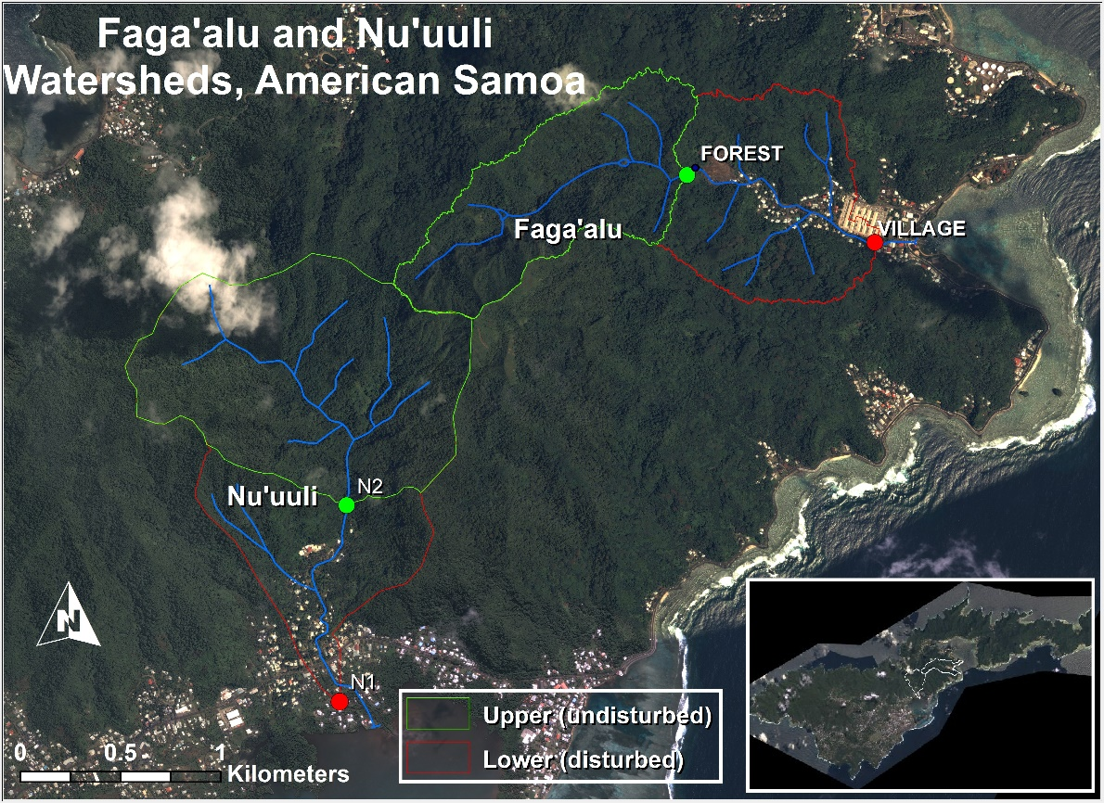

Figure 1 Faga'alu and Nu'uuli watersheds showing upper (undisturbed) and lower (human-disturbed) sections. They drain opposite sides of Matafao Mtn., the highest point on Tutuila (653m). Inset shows locations of barometric pressure stations (Tafuna, Faga’alu, NSTP6, Tula). Instrumentation to monitor continuous suspended sediment yield (SSY) was installed at N1, N2, FOREST, and VILLAGE.

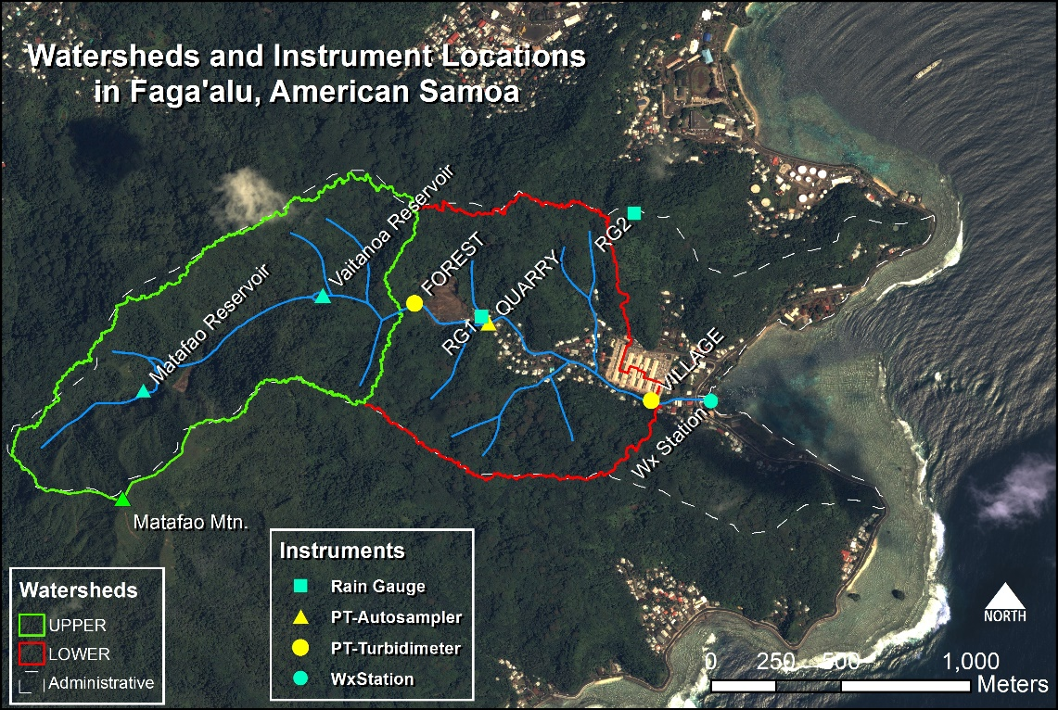

Figure 2 Faga’alu watershed and instrument locations. Grab samples for suspended sediment concentration (SSC) were collected at all three PT locations (FOREST, QUARRY, VILLAGE).

## Methods

A combination of paired- and nested-watershed study designs will quantify the contribution of human-disturbed areas to sediment loading to Faga’alu Bay during baseflow and during events of varying magnitude. The paired watershed approach is used to compare sediment yield from undisturbed and human-disturbed areas in Faga’alu with similar undisturbed and human-disturbed areas in Nu’uuli. The nested watershed approach is used to construct a sediment budget, and to assess the contributions of undisturbed and human-disturbed areas to total sediment loading.

While steep, mountainous streams can discharge a high amount of bedload (Milliman and Syvitski, 1992), this research is focused on sediment size fractions that can be harmful to corals (Bartley et al., 2014). These are the particle sizes that can be transported in suspension in the marine environment to settle on corals and this is generally restricted to silt and clay fractions (<16um) (Asselman, 2000).

Sections 2.4.1-2.4.4 below describe the equations used to quantify sediment loading, disturbance ratio, and the sediment budget. Section 2.4.5 details the field methods used to collect the data required for the calculations.

### Estimating event suspended sediment yield (SSYEV)

Annual or seasonal total SSY can be used to quantify the spatial and temporal patterns of sediment loading (Fahey et al., 2003), but annual totals can be influenced by climatic variability, leading to uncertain assessments of human impact and management effectiveness for the full range of storm sizes and interannual variability in storm number, size, and sequence. Another approach is to assess changes in the sediment rating curve (Q-SSC relationship) (Walling, 1977). but it is complicated by hysteresis effects and is difficult to compare between watersheds (Asselman, 2000; Zimmermann et al., 2012). Preliminary data from the study site showed only weak correlation between Q and SSC, with significant hysteresis during storm- and baseflows.

An alternative approach to detecting human impacts on SSY is to compare SSY generated by storm events of the same magnitude. Total SSY from a storm event (SSYEV) is found by summing continuous suspended sediment load (Duvert et al., 2012):

|  |  |  |
| --- | --- | --- |
|  |  | Equation 1 |
| where *SSYEV* is suspended sediment yield (tons) from 0=storm start to T=storm end, *SSC* is suspended sediment concentration (mg/L), and *Q* is discharge (L/sec). | | |

Storm events can be defined by precipitation (Hicks, 1990) or discharge parameters (Duvert et al., 2012), and the method used to separate storm events on the hydrograph can significantly influence the analysis of event-based SSY (Gellis, 2013). Complex graphical or rule-based techniques for hydrograph separation may be implemented (Dunne and Leopold, 1978), but for this research the simple stage height threshold rule was used due to the flashy hydrologic response, low baseflow discharge, and short duration of recession curves between events (Fahey et al., 2003; Lewis et al., 2001).

### Sediment budget

A sediment budget quantifies the contribution of key sediment sources to the overall sediment yield (Bartley et al., 2012; Reid and Dunne, 1996; Slaymaker, 2003; Warrick and Mertes, 2009). Both Nu’uuli and Faga’alu watersheds were separated into nested watersheds for analysis, following a similar scheme. The total watershed (TOTAL), draining to VILLAGE in Faga’alu and N1 in Nu’uuli, was separated into two nested subwatersheds: the upstream, undisturbed forest portion of the watershed (UPPER), and the downstream, human-disturbed portion of the watershed (LOWER) (Figure 1). In Faga’alu, an additional subwatershed, draining to QUARRY, was delineated and analyzed to assess the contribution of this key sediment source.

The percent contribution of each subwatershed to SSY from the total watershed is calculated by difference between SSY observed at the upper and lower monitoring stations for each storm event. The disturbance ratio (DR) is the ratio of SSYLOWER under current conditions (=SSYTOTAL - SSYUPPER) to SSYLOWER under pre-disturbance conditions (SSYLOWER.pre) :

|  |  |  |
| --- | --- | --- |
|  |  | Equation 2 |

SSYunder pre-disturbance conditions (SSYLOWER.pre) is calculated assuming that the specific SSY from forested parts of the lower watershed is similar to the specific SSY from the upper watershed:

|  |  |  |
| --- | --- | --- |
|  |  | Equation 3 |

The percent contribution and DR were calculated for each storm and averaged to determine the average contribution of each subwatershed to total sediment loading.

It is hypothesized that the disturbance ratio is highest for small storms, when background SSY from the undisturbed forest is low and erodible sediment from disturbed surfaces in the lower watershed is the dominant source, but for large storms mass movements and bank erosion contribute to naturally high SSY from the undisturbed upper watershed, reducing the DR for large events.

### Predicting SSYEV

Sediment yield during a storm event (SSYev) may be correlated with precipitation or discharge variables (“storm metrics”). Four predictors used in this research were total event precipitation (Psum), EI30 rainfall erosivity (EI30) (Hicks, 1990), total event discharge (Qsum), and maximum event discharge (Qmax) (Duvert et al., 2012). Predictor variables may be linearly or nonlinearly correlated with SSYEV, so both Pearson’s and Spearman’s correlation coefficients between SSYEV and each of the predictor variables will be calculated from non-transformed data to select the best predictor of event SSY from each subwatershed and from the total watershed.

The relationship between event SSYEV and storm metrics is often best fit by a watershed-specific power law function of the form:

Equation 2 SSY-Qmax Power function

|  |  |  |
| --- | --- | --- |
|  |  | Equation 4 |
| Where X is a characteristic of a storm, and the regression coefficients α and β are obtained by ordinary least squares regression on the logarithms of *SSYev* and *Qm* (Basher et al., 2011; Duvert et al., 2012; Hicks, 1990). | | |

Linear functions were fit to untransformed (Linear) and log-transformed data (Power Law), and coefficients of determination (r2) were calculated to determine best fit.

Equation 4 may also be normalized to watershed area, which facilitates comparison among watersheds of different sizes, including other watersheds studied in existing literature (Duvert et al, 2012).

### Field Data Collection

A combination of continuous measurements of precipitation, turbidity and water stage, and grab samples of water collected during baseflow and storm events were used to calculate SSYEV and storm characteristics at five sampling locations (FOREST, QUARRY, VILLAGE, N1, and N2). Data were collected over three main field campaigns and several periods of unattended monitoring from January, 2012, to March, 2014. In situ instrument data is currently being downloaded monthly, and another field campaign is planned for October 2014 to January 2015. Field campaigns coincided with the wet season and high storm probability. Three field campaigns were conducted: January-March 2012, February-July 2013, and January-March 2014. More detailed description of data collection and methods can be found in the Appendix and the companion document “Quality Assurance Project Plan: Physical Monitoring of Surface Waters in American Samoa.” In brief, rain gauges were installed at three locations in Faga’alu and at two locations in Nu’uuli; pressure transducers were installed at upstream and downstream locations in Faga’alu (FOREST, VILLAGE) and Nu’uuli (N1 and N2), and rating curves relating stage to discharge were calculated from a combination of field data collection and hydraulic models. Grab samples for SSC were collected for a total of xx storms in Faga’alu and xx storms in Nu’uuli, with a goal of sampling xx more storms at in each watershed during Fall 2014.

Turbidimeters (Greenspan TS3000, YSI 600OMS, and CampbellSci OBS500) were installed at four locations (FOREST, VILLAGE, N1 and N2). Continuous SSC is calculated from 15 min interval turbidity data (T) and a T-SSC relationship calibrated with SSC grab samples over a range of turbidity values (Gippel, 1995; Lewis, 1996). If turbidity data are unavailable but sufficient stream water samples are collected during a given storm (n>3?), SSY is calculated directly using event mean concentration of SSC samples (Harmel et al., 2006b; Lewis et al., 2001). Due to logistical and financial constraints, continuous event-based SSY using turbidimeters could only be measured upstream (FOREST, N2) and downstream of the villages (VILLAGE, N1). To sample SSY from the quarry, a key sediment source in Faga’alu, an ISCO 3700 Autosampler was installed (QUARRY, Figure 2) to collect stream water samples at 30 min intervals during storm events. SSYEV at QUARRY was calculated from event mean concentration (EMC) (Bartley et al., 2012) and the specific discharge from forested areas using discharge data from FOREST, and bare soil using the SCS Curve Number approach (Garen and Moore, 2005).

### Uncertainty

Uncertainty in sediment yield calculated from Equation 1 with input data from turbidity meters and streamflow measurements arises from both measurement and model errors (Harmel et al., 2006a). Harmel et al. (2006a) provides a lookup table for measurement uncertainty for standard field methods for stream discharge measurement with a flowmeter and grab samples analyzed gravimetrically for SSC. Here I assume that field methods are appropriately chosen and implemented, so the additional model errors in estimation of SSY are related to uncertainty in estimates of Q and SSC, which are calculated using stage-discharge rating curves (Q) and the T-SSC relationship (SSC) (Harmel et al., 2009).

Methods for estimating uncertainty in the final SSY estimate include Monte Carlo methods (Navratil et al., 2011; Zimmermann et al., 2012), uncertainty extremes (Warrick and Mertes, 2009), and the Root Mean Square Error (RMSE) method (Topping, 1972); but the RMSE method was chosen due to its simplicity and acceptance in hydrologic studies (Harmel et al., 2009). The RMSE method estimates the ‘‘most probable value’’ of the cumulative or combined error by propagating the error from each procedure (Stage-Q, T-SSC) (Topping, 1972). The resulting cumulative probable error (uncertainty) is the square root of the sum of the squares of the maximum values of the separate errors:

|  |  |  |
| --- | --- | --- |
|  |  | Equation 3 |
| where PE is the cumulative probable error for individual measured values (±%), EQmeas = uncertainty in individual discharge measurements (±%), ESSCmeas = uncertainty in suspended sediment concentration measurements (± %), EQmod = uncertainty in discharge modeled by the Stage-Q relationship (±%), ESSCmod = uncertainty in suspended sediment concentration modeld by the T-SSC relationship (± %), (Harmel et al., 2009). | | |

PE will be calculated for each storm event to add statistical measures of uncertainty to estimates of SSYEV. The effect of uncertain values of SSY on the hypotheses tested about sediment yield and SSY-Qmax relationships will be tested by visual inspection. If the uncertainty estimates and confidence values significantly overlap, it will be difficult to make conclusions about differences in SSY from the subwatersheds, given the high amount of uncertainty in the measurements. This is common in sediment yield studies where successful models estimate SSY with ±50-100% accuracy (Duvert et al., 2012), but it is believed that the difference in SSY from the upper and lower watershed will be significantly larger than the uncertainty in the measurements.

## Expected Results/Outcomes

It is hypothesized that human land use in Faga’alu, mainly by open-pit aggregate mining, has significantly increased terrigenous sediment loading to the bay above the undisturbed baseline. This will be tested by 1) comparing Q-SSC relationships measured below the undisturbed and disturbed watersheds, 2) average Disturbance Ratio and percent contribution to total sediment load, and 3) comparing event-based SSY rating curves from the undisturbed and disturbed watersheds. These analyses will provide novel data on SSY under natural and disturbed conditions from small, mountainous watersheds on volcanic, Pacific Islands.

The resulting empirical model of event-based suspended sediment yield to Faga’alu Bay will be used by NOAA’s Coral Reef Conservation Program (CRCP) to assess the effectiveness of future sediment mitigation at the quarry, and as a component of a top-down model of sedimentation on the reef developed in Paper Three. The developed models of SSY are also useful for advancing research efforts towards regional and global prediction of SSY from peak discharge in small mountainous watersheds (Duvert et al., 2012).